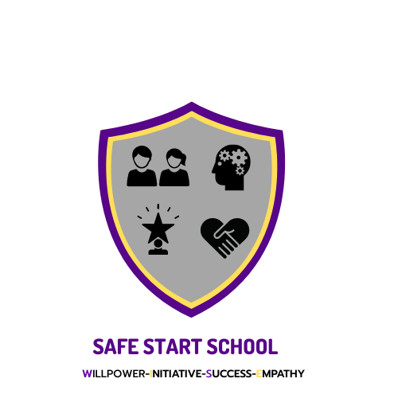
Careers Guidance Policy
2024/25

CAREERS AND GUIDANCE POLICY
Policy Created: November 2024
Reviewed by: G Speakman
Review Date: November 2025
INTRODUCTION
Safe Start education is committed to providing Careers Education, Advice and Guidance to all students through the curriculum and organised activities.

Careers Guidance will focus on the specific needs of the individual student to promote self awareness and personal development.

It will aim to provide current and relevant information to enable each student to make informed decisions about their future. It will be presented in an impartial manner, be confidential and differentiated to suit the requirements of each individual student.

All students will leave the school with the skills and knowledge required to support their entry to further education or employment.
The school actively promotes parent/carer involvement through events, forums and ensuring access to information throughout the year.

GATSBY BENCHMARKS
As a team at Safestart Tameside we will ensure that we are continually working to meet all the below benchmarks linking careers advice and guidance with work placement opportunities.

Have a stable careers programme- All staff, students and employers will have a clear understanding of the work experience programme and all will embed and work towards during year 10 and 11. Year 8 and 9 will have the opportunity to work towards vocational tasters in preparation for years 10 onwards.
Learn from career and labour market information- All students and parents have access to quality support in planning future study options and accurate information for further study and labour market opportunities. Staff to develop skills and keep up to date with current industries.
Addressing the needs of each pupil- Every pupil is individual, will need careers guidance at different stages of their development. Opportunities will be tailored to individual students and ensure equality for all. All students are provided with a range of opportunities which aim to represent our diverse school community. As a school we aim to remove the barriers that our students may face when entering the next steps in their education.
Linking curriculum learning to careers- All staff should highlight the link between core subjects, careers and skills that the pupil is developing to ensure that the pupil engages with the learning and be able to link the need to knowledge and skills in the right context in future employment.
Encounters with employers and employees experience of workplace -Every student should have multiple opportunities to learn from employers about work, employment and the skills that are valued in the workplace. This can be through a range of enrichment activities including visiting speakers, mentoring and enterprise schemes
Encounters with further and higher education personal guidance- All students should understand the full range of learning opportunities that are available to them. This includes both academic and vocational routes and learning in colleges, universities and in the workplace. Vocational work experience should help to embed future career choices when in Year 11 ready for progression.
Experiences of work places- Every pupil should have first-hand experience of the workplace through work visits, work shadowing and/or work experience to help their exploration of career opportunities and expand their networks
Personal guidance- Every pupil should have opportunities for guidance interviews. These should be available whenever significant study or career choices are being made. They should be expected for all students but will be timed to meet their individual needs.
Through the implementation of all the above benchmarks we will focus on personal development which will enable community inclusion, independent skills and employability.
IMPLEMENTATION
All staff are expected to contribute to Careers Education and Guidance (CEG) delivery through their roles as tutors, subject teachers and support staff.
ENTITLEMENTS
Students are entitled to careers education and guidance that is impartial and confidential. It will be integrated into their experience of the whole curriculum, based on a partnership with students and their parents/carers.

The advice and guidance will promote equality of opportunity, diversity and inclusion, whilst promoting the best interests of the students to whom it is given.

Safe start work with Positive steps who are fully Level 4 qualified career, information and advice advisors.
PROVISION
- Careers resources will be available on SafeStart website and are relevant and updated regularly.
- Access to careers software (National Careers Service website) and the internet is easily available.
- Participation in activities, both in school and off-site, provide employer contact and further information.
- Careers guidance will include activities about work to develop knowledge and skills.
.

KEY STAGE 4 PROVISION
- A weekly work experience placement, dependent upon students need, may be offered from year 10 summer term onwards which focuses on students’ future career aspirations, allowing learning about work through the experience of work
- College presentations
- Careers interview for Year 11 students
- Information on college open days
- Support with completing college application forms
- Mock interviews, where deemed advantageous
- Supported CV and personal statement sessions within employability lessons
- Close monitoring of vulnerable students
- Guest speakers and ex-students on work routes
- Vocational lessons added to timetable if required

By the end of stage 4, all students will have:

- Enhanced their self-knowledge, career management and employability skills
- Used ICT software and other sources of advice to investigate and explore future choices and progression routes
- Experienced the world of work through a work placement if applicable
- Given direct access to employers, colleges and training providers
- Given guidance to help identify and access a range of post-16 options and careers advice and given support networks that they can use to plan and negotiate their career pathways.
- Been provided with the resources and training to complete the post-16 application procedures, including CVs, personal statements, and preparation for interview
- Been given information about appropriate available funding
- Produced a challenging but realistic plan for their future learning and work, by relating their abilities, attributes and achievements to the goals they have set themselves.
PARTNERSHIPS
The school works with a range of partners to deliver the CEG programme. These include:

Post 16 providers and higher education institutions
Employers and training providers
Parents/carers
Positive Steps

STAFF DEVELOPMENT
Staff training needs are identified in conjunction with the Head teacher. Training needs are identified and offered to all relevant staff as opportunities arise. Information is then brought back into school and shared with other staff members
MONITORING, REVIEW AND EVALUATION
The annual CEG improvement plan will be reviewed with the school quality improvement plan. It will be reviewed annually by the Senior Leadership Team. Aspects of the programme are regularly evaluated by students using verbal discussion/surveys.

